**Illinois Natural Areas Stewardship Grant Program**

**2023 Manual**

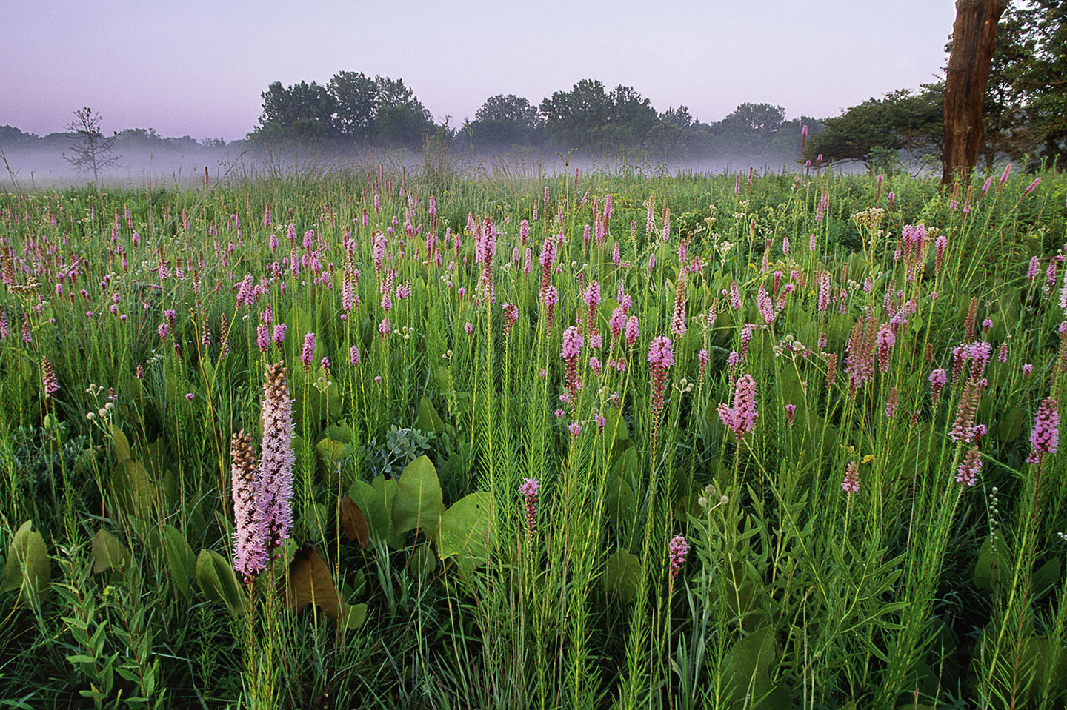

Photo Credit: Dan Kirk

Application are now being accepted for Illinois Natural Areas Stewardship Grant Program through June 16, 2023.

# Overview

The Illinois Natural Areas Stewardship Grant Program purpose of the grant program is to: 1) Increase stewardship on dedicated Illinois Nature Preserves and registered Land and Water Reserves through grants to Conservation Land Trusts, and 2) Increase stewardship capacity within Conservation Land Trusts.

Funding for this grant program is derived from the Illinois Natural Areas Acquisition Fund (NAAF) and must be used by the Illinois Department of Natural Resources (Department) for the acquisition, protection, and stewardship of natural areas, including habitats for endangered and threatened species (Open Space Lands Acquisition and Development Act, [525 ILCS 35/14](https://www.ilga.gov/legislation/ilcs/ilcs3.asp?ActID=1741&ChapterID=44)). Stewardship actions funded by this grant program must be included in the management schedules approved by the Illinois Nature Preserves Commission. Eligible costs may include staff time related to the project, equipment and materials necessary to complete stewardship projects such as tools, safety items, herbicide, construction materials, and indirect costs. Benefit costs are not eligible.

Eligible applicants must be Conservation Land Trusts exempt from taxation under Section 501 (c) (3) of the federal Internal Revenue Code and include in its purposes the restoration and stewardship of land for conservation purposes. Non-Governmental Organizations whose primary purpose is to fundraise for local government conservation agencies are not eligible.

The total funding available for 2023 will not exceed $750,000.00. By Administrative Rule, maximum funding to one project is $100,000. There is a 5% or $1000 matching fund requirement, whichever is less on each project.

Length of grant term will be no more than two (2) years and will be paid on a reimbursement basis at the end of the project unless other arrangements are provided in the grant agreement.

# Background

Created by the Illinois Natural Areas Stewardship Act ([525 ILCS 31](https://www.ilga.gov/legislation/ilcs/ilcs3.asp?ActID=3814&ChapterID=44)/) on 8-25-2017, this opportunity is funded by a portion of the capital apportionment of the Natural Areas Acquisition Fund. The grant program created by the Act and its associated Administrative Rule ([17 Ill. Adm. Code 3051](https://www2.illinois.gov/dnr/adrules/documents/17-3051.pdf)) enjoyed strong stakeholder support from numerous environmental organizations in Illinois, most notably the Prairie State Conservation Coalition, an organization comprised of Conservation Land Trusts in Illinois. Grants must be used to perform approved stewardship actions on lands protected by the Illinois Nature Preserves Commission as dedicated Nature Preserves or registered Land and Water Reserves. Grants may only be awarded to Conservation Land Trusts.

Available funding for the grant program will be determined annually by the Department but cannot exceed $2,000,000 annually. Per statutory language, the grant program cannot adversely impact the Departmental operations funded by NAAF.

# Eligible Lands

* Land dedicated by the Illinois Nature Preserves Commission as an Illinois Nature Preserve, dedicated buffer, or registered as a Land and Water Reserve.
* Preserve/Reserve must have a current management schedule approved by the Illinois Nature Preserves Commission.
* Conservation Land Trusts can work on eligible land owned by another entity provided there is a properly executed agreement between the Conservation Land Trust and the landowner, and the Illinois Nature Preserves Commission has been notified of this agreement at the time of application. The agreement must be in effect at minimum through the end of the grant term.
* Work on land owned by the Illinois Department of Natural Resources is discouraged unless the qualifying and/or significant feature receiving work crosses an IDNR boundary and inclusion of the IDNR portion of the feature is critical for the success of the stewardship project. Other exceptions may be considered by the grant reviewers.

# Eligible Project Expenses

Grant assistance may be obtained for the following activities:

1. Stewardship activities. Eligible projects include, but are not limited to, stewardship of land or water for the following:
   1. Stewardship actions identified in a current, approved management schedule which are designed to maintain, preserve, or improve the condition of native natural communities, diversity of species, and ecological processes,
   2. control of exotic and invasive species,
   3. prescribed burns, or
   4. restoration/enhancement of native plant communities.
2. Contractual services for any eligible project,
3. Purchase and rental of supplies and equipment such as:
   1. UTVs, trailers, sprayers, seed, herbicide),
   2. personal protection items (except boots),
   3. hand tools,
   4. radios,
4. Staff time (excluding benefits)
5. Indirect Costs

# Goals of the Program

The overriding goal of the grant program is to increase the delivery of much needed stewardship activities to natural areas protected within the Illinois Nature Preserves Commission system. Stewardship needs on natural areas throughout the state have continued to outpace the ability to deliver these services by individuals, volunteers, organizations and government agencies. The Program is designed to fund projects that immediately address this deficiency and begin to expand on the stewardship capacity of Conservation Land Trusts through grants that will expand their staff and equipment for these activities.

# Program Priorities

All eligible projects will be considered for funding in 2023. However, in the current year of the grant program, projects are encouraged that address both purposes of the Act:

1) Increase stewardship on dedicated Illinois Nature Preserves and registered Land and Water Reserves through grants to Conservation Land Trusts, and

2) Increase stewardship capacity within Conservation Land Trusts.

Additionally, there will be a focus on addressing the most urgent needs where the qualifying feature protected by the Illinois Nature Preserves Commission is at risk of being lost.

# Grant Program Rules and Guidelines

1. Applications will be screened for applicant eligibility.
2. Applicants must register in the Grant Accountability and Transparency Act (GATA) system prior to applying: [www.grants.illinois.gov/portal/](http://www.grants.illinois.gov/portal/)
3. Apply Online here: <https://il.amplifund.com/Public/Opportunities/Details>
   1. Uniform Application for State Grant Assistance (you will complete this document online in the [Amplifund](https://il.amplifund.com/Public/Opportunities/Details) portal)
   2. Project Narrative (template for your use on the [Natural Areas Stewardship Grant webpage](https://dnr.illinois.gov/grants/stewardshipgrants.html) – final completion and submittal is required online in the [Amplifund](https://il.amplifund.com/Public/Opportunities/Details) portal), information requested includes the following:
      1. Project Summary
      2. Conservation Land Trust Summary
      3. Capacity/Leveraging
      4. Site Information
      5. Qualifying Features
      6. Stewardship Action Summary, including maps of project locations
      7. Expected Outcomes and Benefits
      8. Additional Benefits, including alignment with statewide efforts
         1. [Illinois Natural Areas Plan](https://naturalheritage.illinois.gov/content/dam/soi/en/web/naturalheritage/documents/Illinois%20Natural%20Areas%20Plan.pdf)
         2. [Illinois Sustainable Natural Areas Vision](https://naturalheritage.illinois.gov/content/dam/soi/en/web/naturalheritage/documents/Illinois%20Sustainable%20Natural%20Areas%20Vision.pdf)
         3. [Illinois Wildlife Action Plan](https://dnr.illinois.gov/content/dam/soi/en/web/naturalheritage/speciesconservation/illinois-wildlife-action-plan/implementing-the-plan/Implementation_Guide_2022revised.pdf)
      9. Statement of ability to complete work within the grant period
      10. Conflict of Interest disclosure
   3. For projects occurring on land not owned by the applicant, 1) a copy of the executed agreement between the Conservation Land Trust and the landowner, 2) a copy of the notification of the executed agreement to the Illinois Nature Preserves Commission to demonstrate it was submitted
   4. Uniform GATA Grant Budget Template and Budget Narrative (you will complete this document online in the [Amplifund](https://il.amplifund.com/Public/Opportunities/Details) portal)
   5. Other items if applicable – visitor use, threat abatement, etc.
4. Other items to be used by the Department in the evaluation of projects will include:
   1. Rarity and condition of the resource
   2. Severity of stewardship need
   3. Ability of applicant to complete the project
   4. Increase in stewardship capacity of the applicant
   5. Applicant’s past performance (if available)
   6. Matching funds
5. Grants are limited to an initial term of two (2) years. Justified requests for an extension received in writing 90 days prior to the end of the grant term may be granted by the Department.

# Budget Guidelines

1. Equipment will be items or a group of items that make up one functional unit valued over $5000.
2. Two price quotes for equipment purchase with value of $5,000 or more.
3. Employee salary and indirect costs are allowed (no benefit costs). In order to charge indirect costs to a grant, the applicant organization must have an annually negotiated indirect cost rate agreement (NICRA). There are three types of NICRAs: a) Federally Negotiated Rate. Organizations that receive direct federal funding may have an indirect cost rate that was negotiated with the Federal Cognizant Agency. Illinois will accept the federally negotiated rate. The organization must provide a copy of the federally NICRA. b) State Negotiated Rate. The organization may negotiate an indirect cost rate with the State of Illinois if they do not have Federally Negotiated Rate or elect to use the De Minimis Rate. The indirect cost rate proposal must be submitted to the State of Illinois within 90 days of the notice of award. c) De Minimis Rate. An organization that does not have a current Federally Negotiated Rate may elect a de minimis rate of 10% of Modified Total Direct Cost (MTDC). Once established, the de minimis rate may be used indefinitely. Applicants may also elect not to include indirect in their grant budgets. Grantees must affirm their selection annually in a system supported by the Grant Accountability and Transparency Unit for the State of Illinois.
   1. Documentation of employee time must be hourly and include a description and location of the work for activities that can be matched to those described in the grant agreement.
4. Expenses prior to the grant term are not allowed.
5. By default, grant expenses will be paid on a reimbursement basis at the end of the project. Periodic payments, e.g., quarterly, are allowed if requested by the applicant and approved by the Department.

# Match

Match is required on all projects. For this grant cycle, the Department will enforce the minimum match requirements allowed by Administrative Rule of 5% or $1000, whichever is less. This is being done to ensure that all land trusts, regardless of size and financial ability will have access to this program.

# Project Evaluation Criteria

Department staff shall evaluate each application presented according to the following Project Evaluation Priorities and Criteria:

|  |  |  |
| --- | --- | --- |
| **Natural Areas Stewardship Grant Evaluation Criteria** | | |
|  |  |  |
| **Narrative Sections** | **Maximum Points** | **Criteria** |
|  |  |  |
| Project Summary | 10 | Scoring based on assessment of stewardship action improving conditions or addressing threats to the qualifying features for which the site was dedicated or registered. |
|  |  |  |
| Conservation Land Trust Summary | 0 | Not scored, used to determine eligibility |
|  |  |  |
| Capacity/Leveraging | 10 | Scoring based on assessment of the project's increase to stewardship and capacity than would otherwise occur. |
|  |  |  |
| Site Information | 0 | Not scored, used to determine eligibility |
|  |  |  |
| Qualifying Features | 15 | Scoring based on assessment of the relationship between the qualifying features and the stewardship action proposed. |
|  |  |  |
| Stewardship Action Summary | 15 | Scoring based on assessment of the appropriateness of the mechanism and method of the stewardship action. |
|  |  |  |
| Expected Outcomes and Benefits | 40 | Scoring based on assessment of whether project outcome maintains or improves the conditions of the qualifying and/or significant features and the urgency of need. |
|  |  |  |
| Additional Benefits | 10 | Scoring based on benefits to implementation of the statewide plans. |
|  |  |  |
| Ability to complete work | 0 | Not scored, used to determine eligibility |
|  |  |  |
| Conflict of Interest Disclosure | 0 | Not scored, used to determine eligibility |

# Grant Consultations

No formal grant consultation process will be established, but staff from the Department’s Office of Grant Management and Assistance, the Division of Natural Heritage and the Illinois Nature Preserves Commission are available to address questions from applicants.

# Release of Information

Application information cannot be kept confidential. Grant applications are considered public information under the Illinois Freedom of Information Act, 5 ILCS 140/2.5

# Submission Instructions

Complete necessary GATA forms at the links indicated above. Submit your application materials through the [Amplifund](https://il.amplifund.com/Public/Opportunities/Details) portal by **5:00pm on June 16, 2023.**

# Performance Reporting

The grantee shall be required to provide reporting of its activities under this project. The DNR may withhold or suspend payment if the grantee fails to submit the required reports. The following reports are required under this Agreement:

* **Quarterly Progress Reports**: If the amount of grant funds awarded exceeds $25,000.00 [30 ILCS 705/4(b)(2)], the grantee is required to provide to the DNR quarterly progress reports containing both the PPR Performance Report that describes the progress of the project, and the PFR Financial Report, that documents expenditures of funds according to the budget line items as detailed in the approved Uniform Application for State Grant Assistance. The Quarterly Progress Report will be due as follows:

Period of Work Quarterly Progress Report Due Before

January 1 – March 31 April 30

April 1 – June 30 July 31

July 1 – September 30 October 31

October 1 – December 31 January 31

* **Annual or Final Report**: The grantee shall submit a written **Final Report** to the Department no later than 30 days following the completion of the Project or the ending date of the grant agreement, whichever is earlier, in accordance with the applicable administrative rules. The Final Report shall include:
* Grant Agreement Number
* Grantee name, address and telephone number
* Timeframe of the report
* Name and telephone number or e-mail address of grantee representative completing the report
* Project objective as described in the application and grant agreement
* Completed Project description
* Photos
* Summary of the Project accomplishments related to the Project goals (if applicable)
* Financial Report: Total project expenditures, itemized and include the following: name and address of vendor, item description identifying details (if applicable), quantity purchased, date item purchased, and project expenditures paid by funds other than Natural Areas Acquisition Funds
* An Equipment Use Report, if applicable
* Any other information requested by the Department

**Equipment:** Equipment purchased shall become the property and the responsibility of the grantee at the end of the grant term, unless specified otherwise in the Grant Agreement

# Contact Information

To contact the Department with questions related to the Natural Areas Stewardship Grant, please use the following means:

By US Mail: Department of Natural Resources

Office of Grant Management and Assistance

One Natural Resources Way, Springfield, IL 62702-1271

By e-mail: [susan.duke@illinois.gov](mailto:susan.duke@illinois.gov)

By phone: Susan Duke 217-785-4416

By fax: (217) 785-2438

Website: <https://www2.illinois.gov/dnr/grants/Pages/default.aspx>