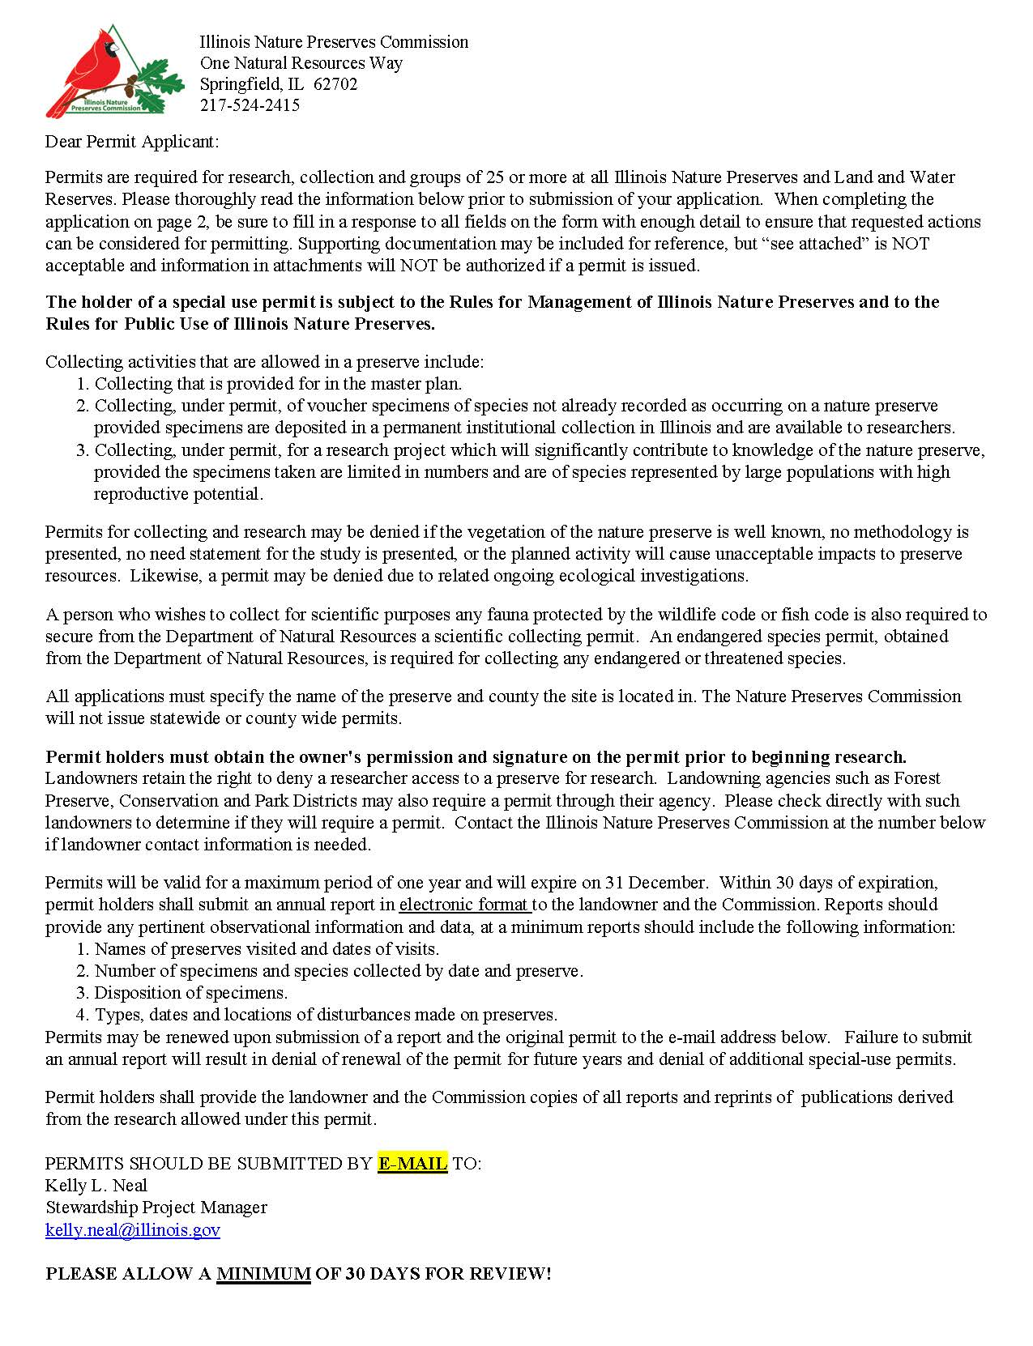

PLEASE ALLOW A MINIMUM OF 30 DAYS FOR REVIEW!

ILLINOIS NATURE PRESERVES COMMISSION
APPLICATION FOR SPECIAL-USE PERMIT

NAME:
POSITION:
ADDRESS:
DATE OF BIRTH: PHONE NUMBER: E-MAIL ADDRESS:
GENERAL FIELD OF INTEREST, PROFESSIONAL QUALIFICATIONS AND INSTITUTIONAL AFFILIATION:

PROPOSED VISITS AND ACTIVITIES
NAME OF PRESERVE(S) or LAND AND WATER RESERVE(S) AND COUNTY:

FREQUENCY AND LENGTH OF VISIT:

DURATION OF PROJECT (WITH DATES):

GENERAL DESCRIPTION OF ACTIVITIES (INCLUDE NUMBER IN PARTY AND USE OF EQUIPMENT IN PRESERVE):

OBJECTIVE OF PROJECT:

METHODS AND PROCEDURES:

RECORDS TO BE KEPT:

COLLECTING (INCLUDING CAPTURE AND RELEASE)
SPECIES OR MATERIAL:

NUMBER OF SPECIMENS:

DISPOSITION OF SPECIMENS:

METHODS OF COLLECTING:

OTHER DISTURBANCES TO BE MADE:

OTHER PERTINENT INFORMATION(LIST ALL PERMITS HELD):

BY MY SIGNATURE, I CERTIFY THAT I HAVE READ AND UNDERSTAND THE PERMIT REQUIREMENTS ON THE BACK OF THIS APPLICATION AND THAT THE ABOVE SUPPLIED INFORMATION IS TRUE AND ACCURATE TO THE BEST OF MY KNOWLEDGE.
X_________________________________________________________________DATE:_________________

