Fox River Status Update
November 13th, 2025

*This Update is based on the current forecast and will be adjusted based on future forecasts and rainfall.

Summary
Start Monday Winter Drawdown begins and will be completed December 1st. This will be the last update until next season, pending any high flow events. There is currently near 0.20” of rain forecasted for the lakes over the next 7 Days (Figure 4). Inflows are forecasted to remain near current levels (Figure 1). Fox Lake, the Upper River, and Pool will all start dropping as drawdown begins (Figure 2). The Lower River is expected to rise starting Monday (Figure 3).

Current Conditions and NWS Forecasts
Figure 1: National Weather Service Forecasted Inflows

Figure 2: Estimated Upstream Gage Heights

Figure 3: Estimated Downstream Gage Height

Current Conditions
Measured flow on the Fox River near New Munster, WI is 364 cfs and Nippersink Creek near Spring Grove is at 29 cfs. The total Stratton inflow is 359 cfs. The Fox Lake stage is 4.09 ft; the Stratton Dam Tailwater stage is 0.93 ft. The Fox River at the Algonquin Dam headwater stage is 1.43 ft.

Forecast
Inflows are forecasted to hold relatively steady for the next week, as shown in Figure 1. Fox Lake and areas upstream of the dam will begin dropping Monday until 2.5’ is reached, as shown above in Figure 2. The Lower River should expect levels to increase during the drawdown, Figure 3. The 7-Day Precipitation forecast is showing 0.20” of rainfall.

Figure 4: 7 Day Precipitation Forecast
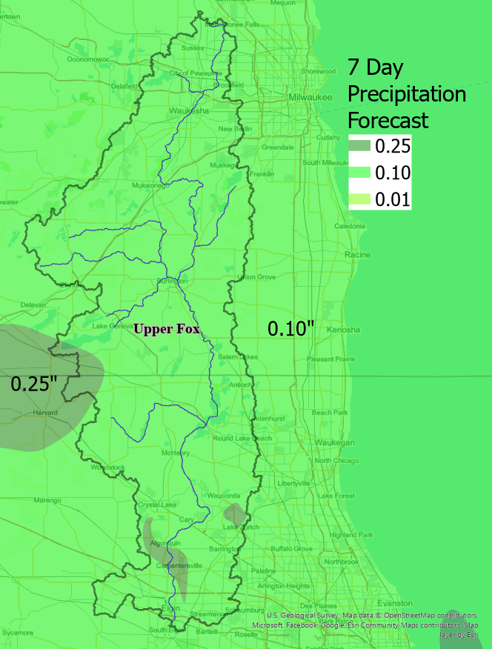

System Outlook

Chain O’ Lakes Outlook
Water levels will start dropping until winter pool is achieved.

McHenry Pool Area Outlook
The Pool and Upper River should expect conditions similar to the lakes.

Lower River Outlook
Water levels will increase until drawdown is completed.

IDNR-OWR will continue to monitor conditions and make changes as necessary pending future forecasts and conditions.

Thank you,

Aaron Rotherham
Office of Water Resources
Illinois Department of Natural Resources

